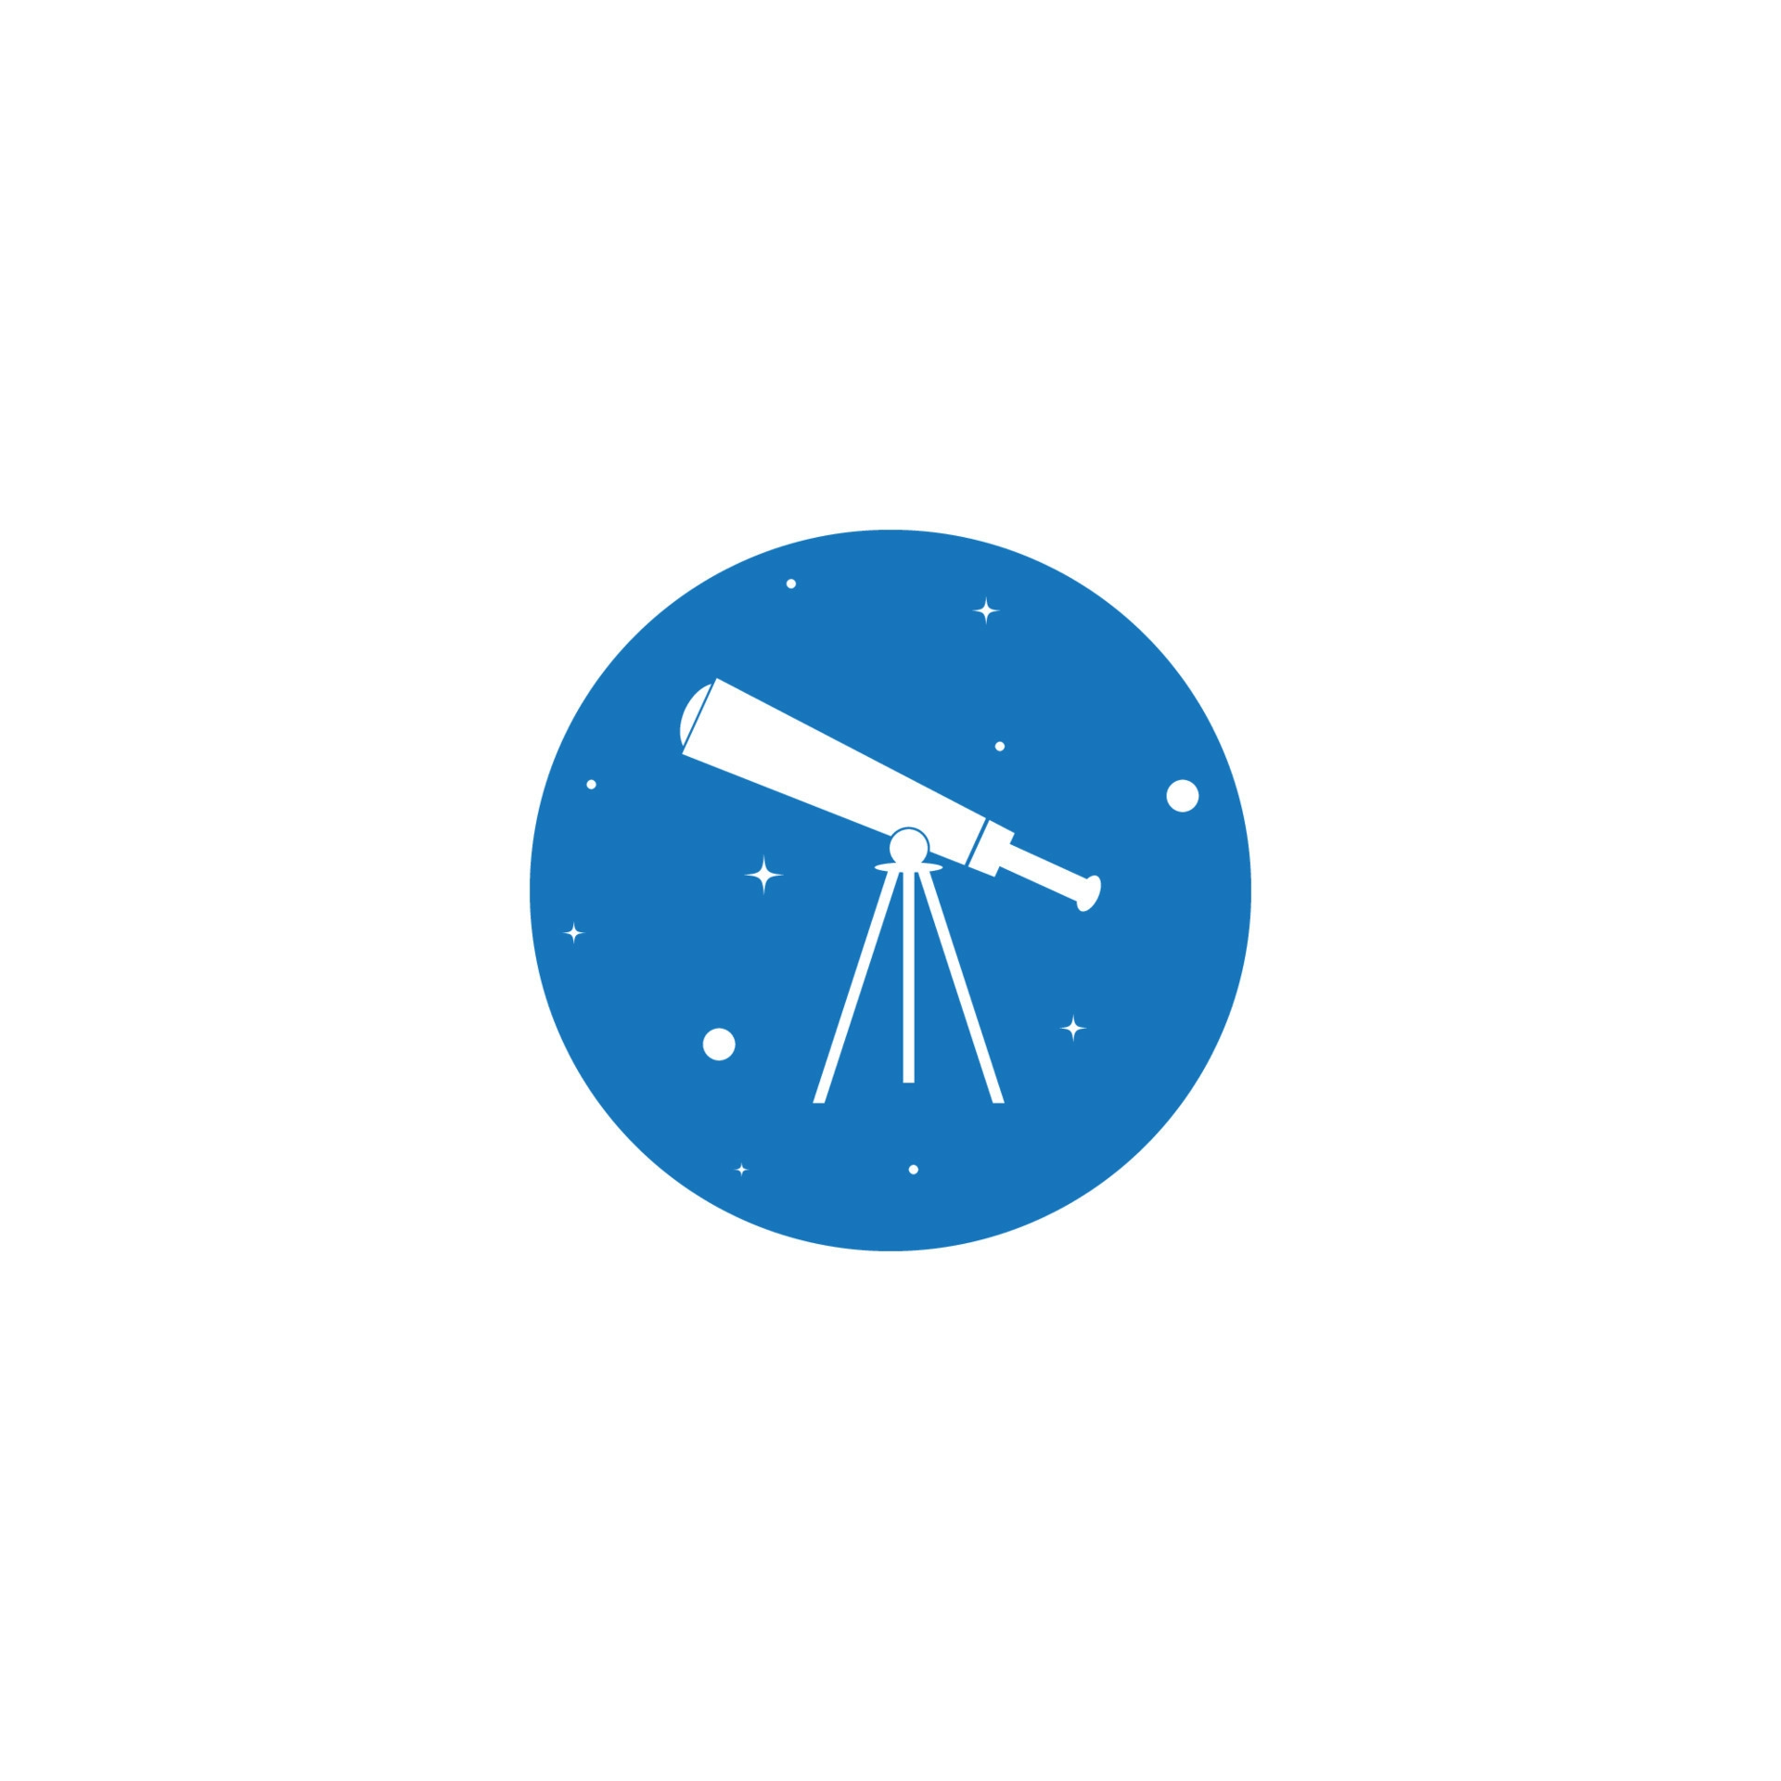

CosmosView

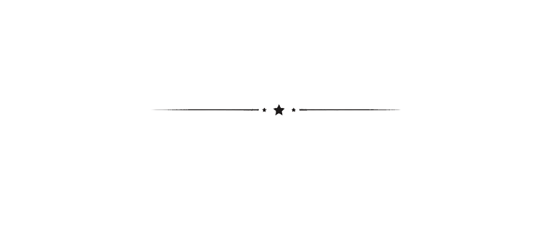

# User Manual

# 

# 

# Copyright © GalacticaTM 2022

# Table of Contents

Introduction 3

Requirements 3

User Interface 3

Control Window 3

Celestial Body Chooser 4

Focus 4

Zoom 4

Moon Phases Slider 4

Keyboard Controls 4

Recenter Button 5

Graphics 5

Telescope Lens 5

Planets 5

Galaxy 6

Moon 6

Description Sidebar 6

Safety 7

Legal 7

Credits 7

Introduction

Thank you for purchasing CosmosView! You are now entitled to a beautiful view of the cosmos. You are no longer subject to light pollution interrupting your view of the beautiful night sky. The most amazing interactive visualization of the night sky is now in your hands!

Requirements

* Processing 3.5.3
* G4P GUI Builder 4.3
* A functioning computer with available storage
* Mouse and keyboard
* A screen 900px wide and 500px tall
* Working hands to operate the software (or get a trusted human operator)
* Minimal familiarity with the concept of a telescope, no experience needed
* The willingness and excitement to use the product :D

User Interface

Control Window

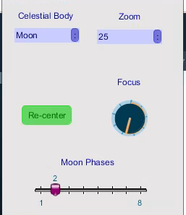

The control window houses all of the changeable options available to you It permits you to alter all of the available options at their leisure.

It consists of five main elements that the user can control for the program, which are explained below.

Celestial Body Chooser

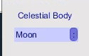

Celestial bodies are chosen from a drop-down menu in the control window. When a body is chosen, it is drawn and its description is printed on the sidebar. The user can choose between the Moon, Venus, Mars, Jupiter, Saturn and Andromeda galaxy to view from their telescope.

Focus

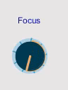

In a telescope, the focus sharpens the image so that you can see it clearly. In the software, the user can adjust the focus of the image by adjusting this knob. They must align it properly to ensure that the image does not come out blurry like one would with a real telescope.

Zoom

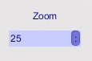

In a telescope, the magnification of the image can be enhanced by changing the eyepiece, which has different zoom values depending on its size. This dropbox allows the user to change the zoom simulating the change in the eyepiece. They can choose a zoom of 25x, 50x and 100x.

Moon Phases Slider

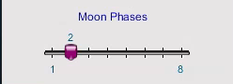

This feature allows the user to change the phase of the moon that they are currently viewing.

Keyboard Controls

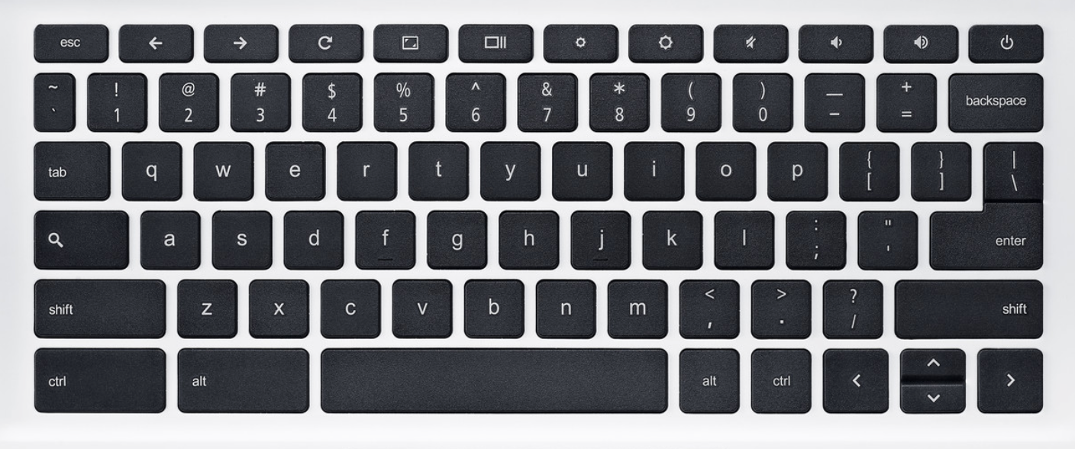

Using the arrow keys, the user can simulate the telescope’s movement.

This will make the image move in the opposite direction (eg. as the telescope moves down, the object appears to move upwards).

Note: The user must click on the main window before attempting to use the arrow keys for movement.

Recenter Button

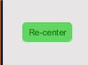

If the user has moved the telescope and would like to recenter it, they can click this button to automatically position the telescope on the centre of the object being viewed.

Graphics

Telescope Lens



A white circle represents the field of view (the area in which the celestial bodies can be viewed) of the telescope, simulating how a real telescope can only view celestial bodies within a certain frame.

Planets

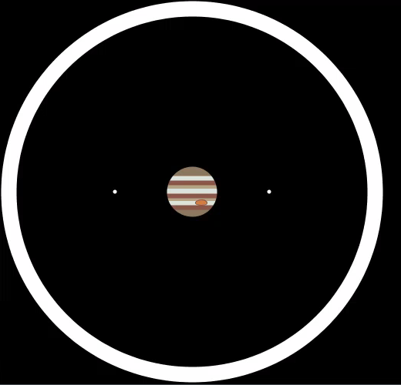

Each planet is drawn at 3 different zooms depending on which zoom the user chooses. Details such as stripes and rings become more visible with more zoom. Planets do not rotate or move in this software because any movement is too slow to notice even with a real telescope.

Jupiter at 25x zoom

Galaxy

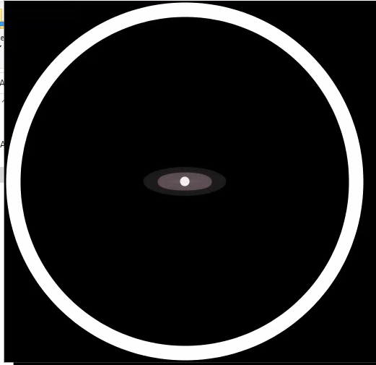

The Andromeda galaxy is composed of concentric ellipses. Just like the planets, the user can choose between 3 zooms for this as well.

Andromeda at 100x zoom

Moon

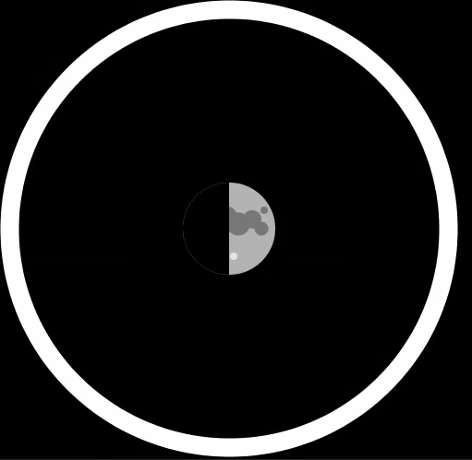

The Moon can be viewed in all zooms and in all of its phases labelled 1-8 on the slider (1: new moon, 2: waxing crescent, 3: first quarter, 4: waxing gibbous, 5: full moon, 6: waning gibbous, 7: last quarter, 8: waning crescent).

Changing the slider will allow users to progress back and forth between phases of the moon.

The Moon 50x zoom in phase 3 (First Quarter)

Description sidebar

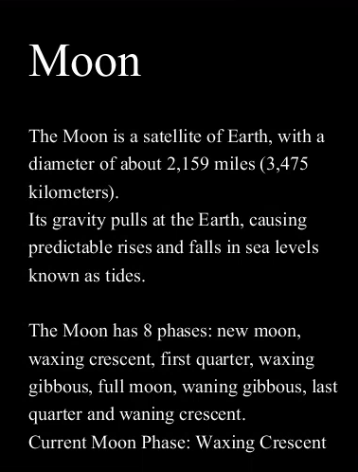

Offers a basic description of the current celestial body in view. Gives basic information on the object being viewed and some fun facts to accompany it.

Safety

Please use CosmosView appropriately and watch where you are going. If you plan on using this program on a mobile device, please proceed with caution when travelling. Please refrain from viewing the app while walking or driving.



Legal

CosmosView asks that all its users thoroughly read and understand the terms of service and end-user license agreements that are in place. It is necessary that users are aware of the terms at the time of purchase. If you experience any issues with the program or have any questions, please contact us at 519-968-7666.

Credits

CosmosView was designed and developed by Anika Sharma, Aaron Ye and Omeed Attayi from GalacticaTM.